**Student grade management - guide**

*By KynNotKien*

**Program menu:**

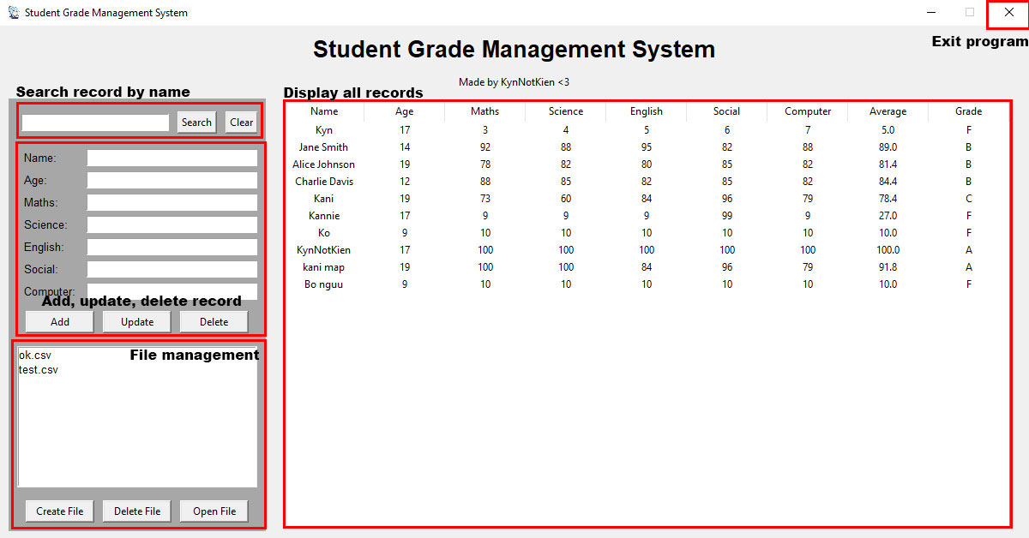

**All requirments are reached!**

* **The program should prompt the user to select an option from the menu.**
  + There are 5 menus so users can use.
* **For adding a record, the user must input name, age and 5 marks.**
  + There will be an error message if any thing is missing.

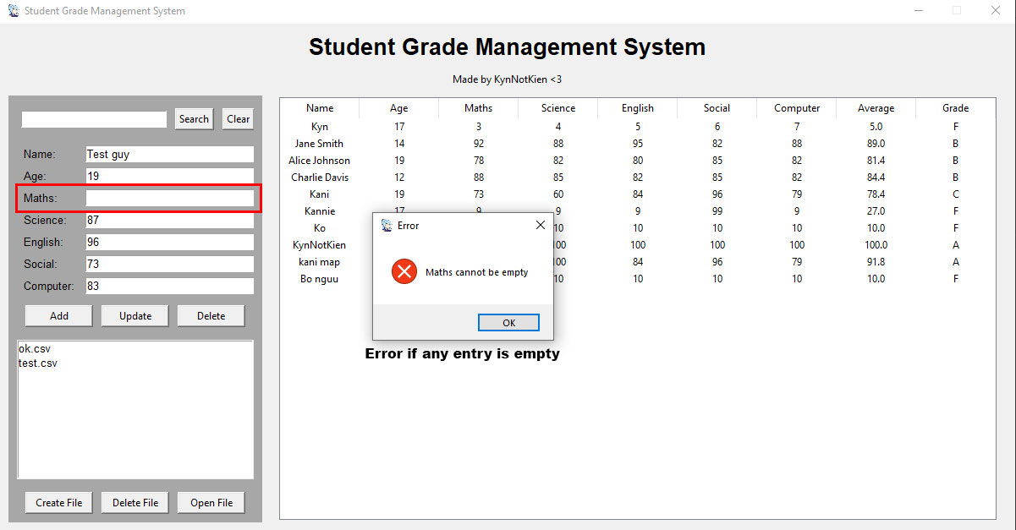

* **Deleting a record should be based on the student's name.**

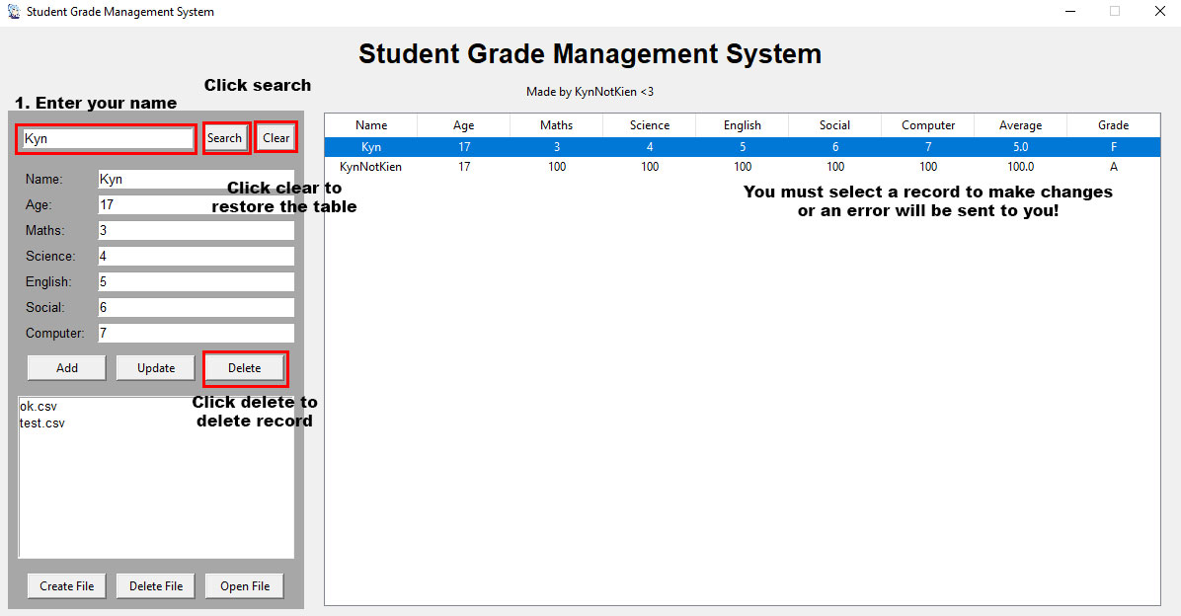

* **Displaying records should show all the records in the database.**
  + All records will be shown in the table, you can scroll if your record amount is too large!
* **The program should calculate the average of 5 marks for each student and store it in the database.**
  + All the scores will be calculated in Average and Grade

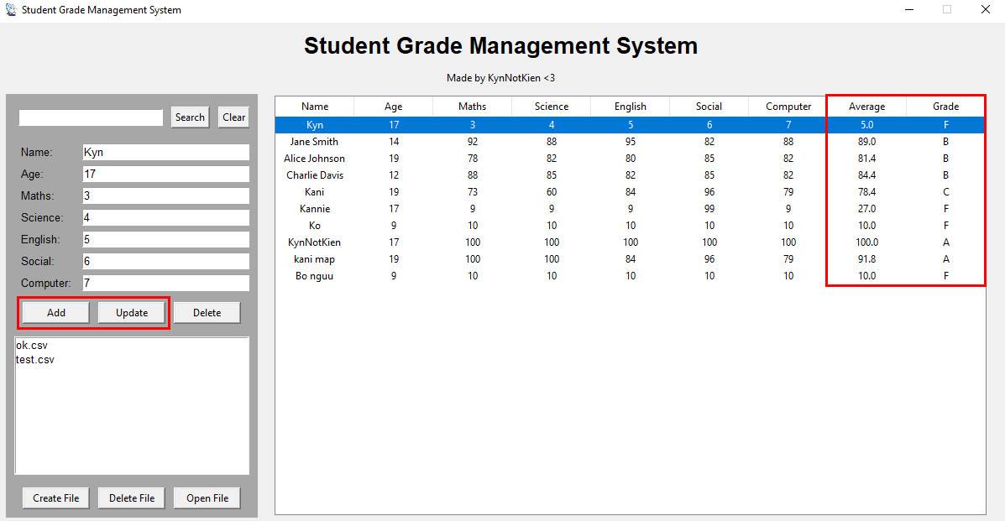

* **Create file**

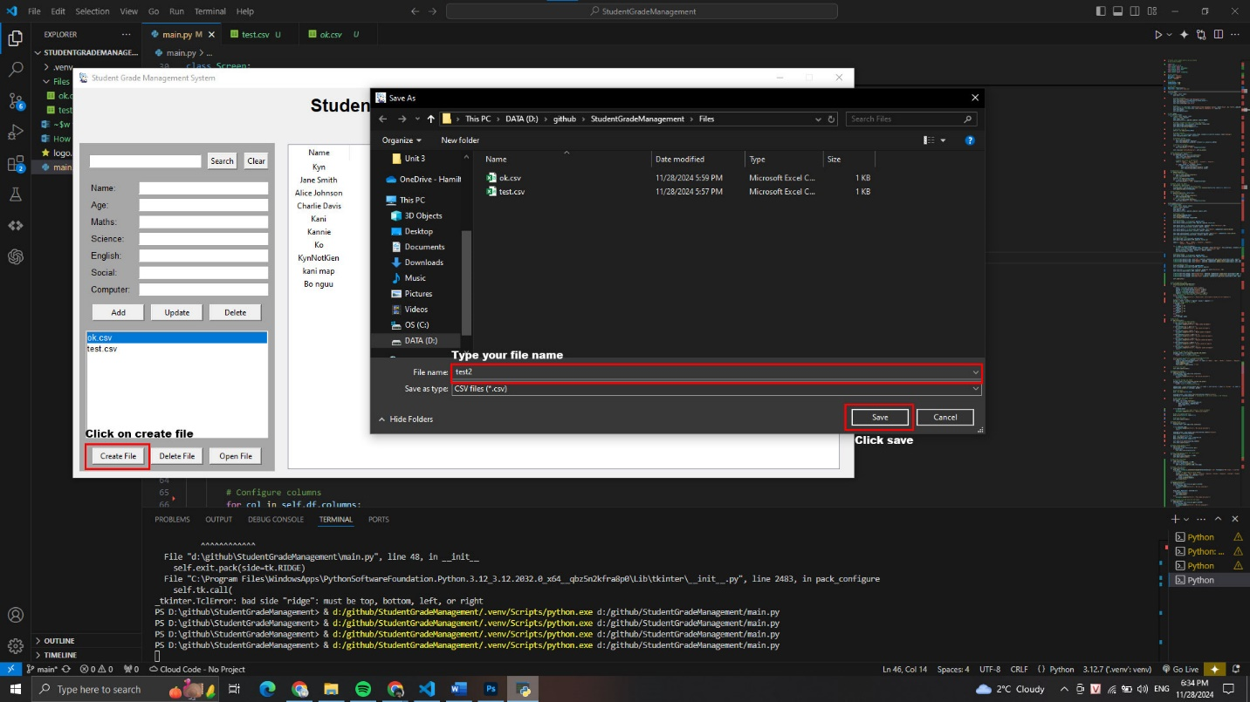

* **Delete File**

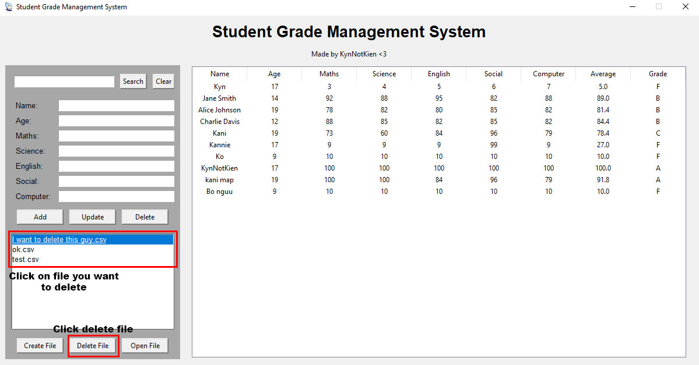

* **Open file**

